**User manual for wimea-ict mobile application**

**Introduction**

Wimea desktop is an application that allows registered users to enter data from the manual stations using their computers whether they have internet or not.

This user manual assumes a user has downloaded the application and has installed it on his/her application

**Starting the application**

To start the application, click on the wimea icon on the application menu

The application displays the login page. The login page contains two inputs i.e. username and the password.

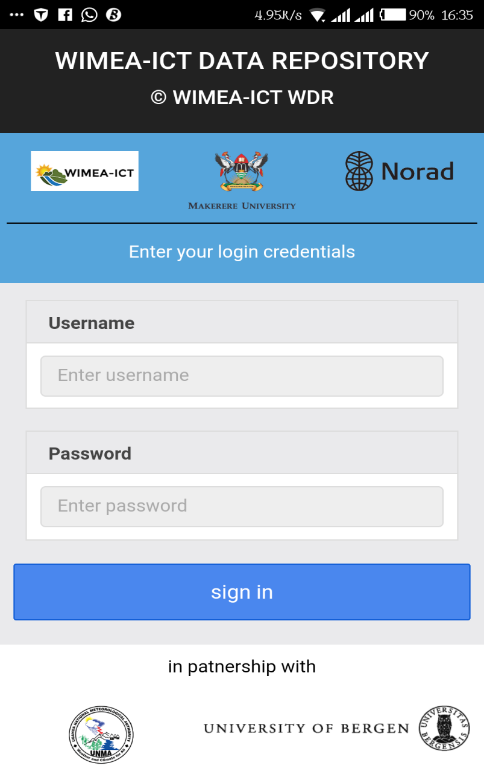

**Application features**

**Login**

If it is the first time to launch the application, you need internet to be able to login while for other times no internet will be required to login.

A user has to enter their usernames and passwords that were created for them in the web system in order to login successfully.

* Enter your username
* Enter your password
* Click on the sign in button

If the credentials are correct the application will display the observation form page as shown below

However when the credentials are wrong the following notification will be displayed as shown below

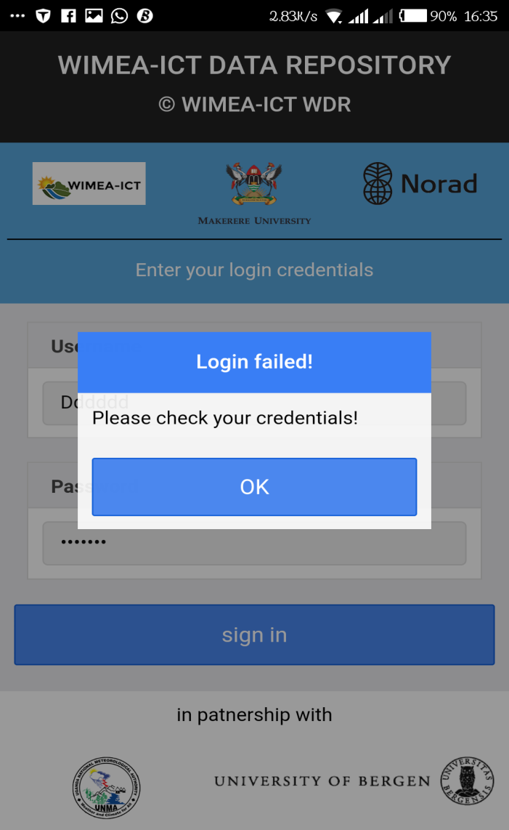

If a user clicks sign in without the credentials entered, the following notification will be shown

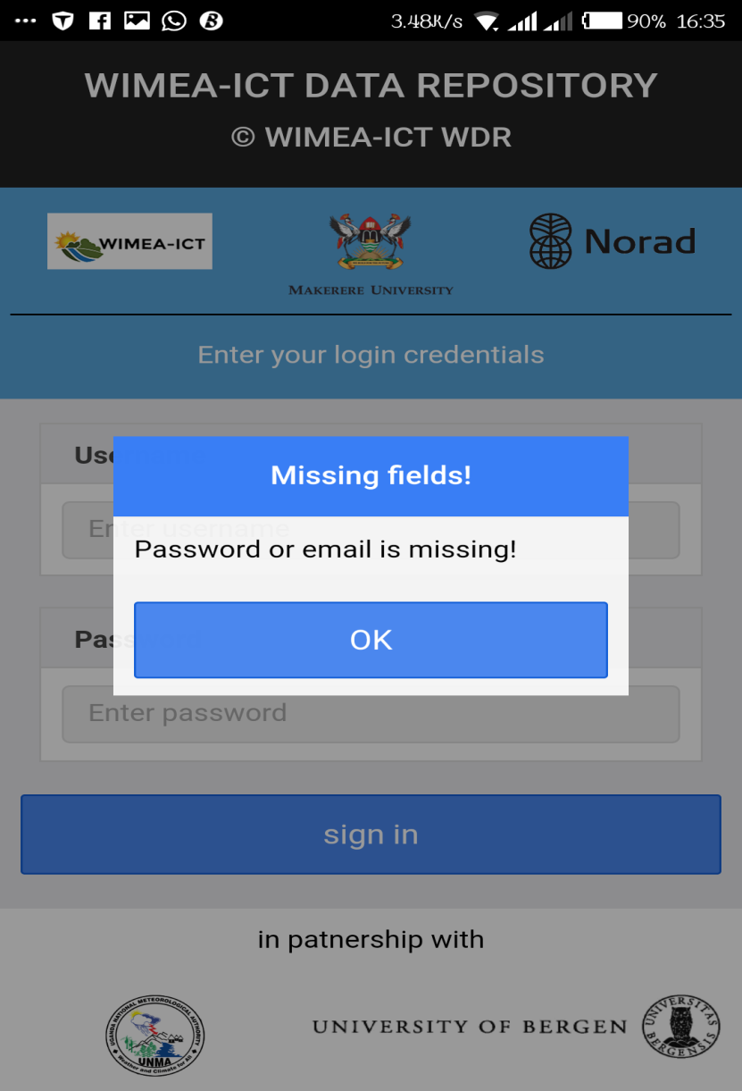

**Observation form**

This form helps users to enter the observation form fields as identified by them at the manual weather stations. This form has validations that require a user to enter before allowing them to continue i.e. Date, time, total amount of all clouds, total amount of low clouds, visibility, wet bulb, dry bulb, wind direction and wind speed.

The observation form is broken down into four sections according to cloud entries, screen entries, office entries and outdoor entries as shown below

A user cannot continue to the other observation sections if the required fields are not filled in by the user as shown below

**Entering data**

To enter data click/ slide out the side menu,

* Select the observation form
* Enter the observation data
* Click to submit

Turn on your internet if you need to submit data online else the data will be submitted offline

When a user clicks the submit button, the following notifications are shown based on the internet status

If internet is available, the following interface is shown

If internet is not available this notification is shown

**Dashboard Side menu**

This menu contains the features provided by the application to allow users perform their activities as shown in the figure below

**Logging out**

Click/ slide to view the slide menu

On the side menu click on the logout button as shown before

**Uploading an offline record**

Click/ slide out the side menu, click the pending uploads menu

Click on any of the items on the list

If you have internet , the application will show a notification prompting to confirm

* Click to confirm submission
* Confirming submission deletes the record from your phone

Else the application will show a notification reminding you to connect your phone to the internet

**Editing an offline record**

To edit a record, click on the pending uploads menu

A menu is displayed showing pending uploads for both the